**FACIAL CLEANSER/WASH**

*SKIN TYPE: OILY*

(PRICES 100 -500)

1. **Pond’s Acne Solution Anti-Acne Facial Foam (100g)**

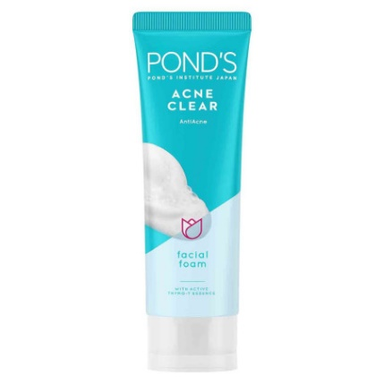

**WHAT IT DOES:** Pond',s Acne Clear Facial Foam is formulated with the world',s first Active Thymo-T Essence, Salicylic Acid, and Vitamin B3+ to reduce impurities, excess oil, and accumulation of acne causing bacteria. It also uses unique Lock + Clear Technology that works in 3 days to eliminate acne at the root, for smooth clear skin.

**HOW TO USE:** Wet your face. Squeeze a pea-sized amount of facial wash on your hand and lather with water. Massage and on face and rinse thoroughly.

**PRICE:** ₱ 195.00

**BENEFICIAL INGREDIENTS:** 2/24 ingr.

**DEBATABLE INGREDIENTS:** 2/24 ingr.

1. **QUICKFX Pimple Eraser Facial Gel Cleanser (75ml)**

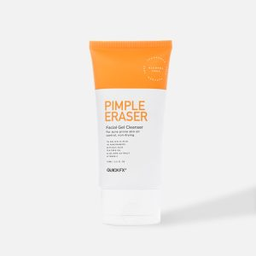

**WHAT IT DOES:** This clarifying Facial Gel Cleanser contains Salicylic Acid technology, providing sustained acne defense even after rinsing plus tea tree oil to fight bacterial growth. With moisturizing and calming ingredients to prevent drying and inflammation, it's designed for troubled, sensitive skin.

**HOW TO USE:** Apply a generous amount of gel wash to dampened face. Lather and rinse

**PRICE:** ₱ 199.00

**BENEFICIAL INGREDIENTS:** 7/19 ingr.

**DEBATABLE INGREDIENTS:** 2/19 ingr.

1. **Neutrogena Deep Clean Acne Foaming Cleanser (40g)**

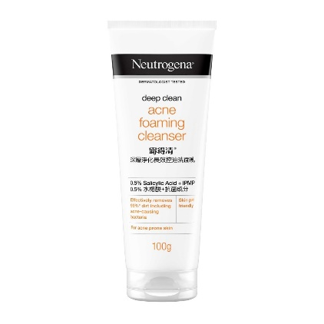

**WHAT IT DOES:** Neutrogena Deep Clean Brightening Foaming Cleanser has skin loving ingredient, the Amino Micellar technology, where pH gentle rich foam cleanses deep into pores without disrupting the naturally good skin barrier. It also contains Niacinamide known to visibly improve uneven skin tone for a radiant complexion. It removes 99%* impurities and micro-pollutants, giving naturally glowing skin. Dermatologist-tested and non-comedogenic.

**HOW TO USE:** Apply to wet face, massage and rinse.

**PRICE:** ₱ 149.00

**BENEFICIAL INGREDIENTS:** 3/19 ingr.

**DEBATABLE INGREDIENTS:** 2/19 ingr.

(PRICES 500 -1000)

1. **La Roche-Posay Effaclar Purifying Foaming Gel (200ml)**

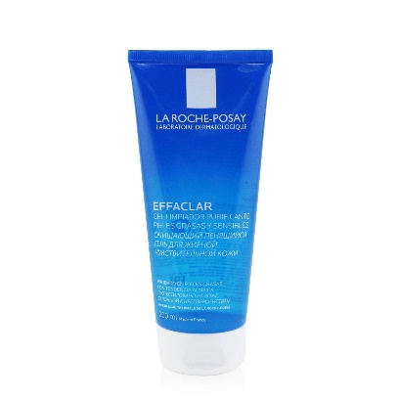

**WHAT IT DOES:** This gentle facial wash for oily skin with zinc pidolate effectively cleanses away dirt and oil while respecting skin's pH balance. Cleanses and purifies skin without over drying. Tested on acne-prone skin (non comedogenicity test).

**HOW TO USE:** Morning and/or evening, massage onto wet skin in a gentle, circular motion. Then, rinse thoroughly and pat dry. Avoid eye area.

**PRICE:** ₱ 690.00

**BENEFICIAL INGREDIENTS:** 3/19 ingr.

**DEBATABLE INGREDIENTS:** 2/19 ingr.

1. **Cetaphil Dermacontrol Oil Removing Foam Wash (237 ml)**

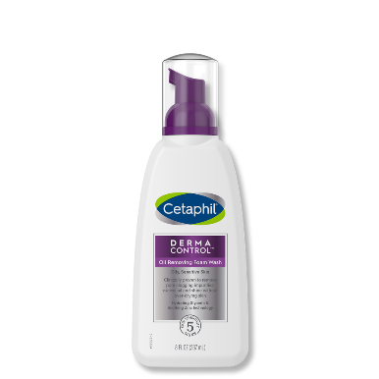

**WHAT IT DOES:** Deep cleansing formula, dispensed through an instant foaming pump, gently removes pore clogging impurities, makeup and excess oil without over-drying skin.

**HOW TO USE:** Massage foam onto damp skin. Rinse.

**PRICE:** ₱ 940.00

**BENEFICIAL INGREDIENTS:** 3/12 ingr.

**DEBATABLE INGREDIENTS:** 3/12 ingr.

1. **SEBAMED Clear Face Care Gel (50 ml)**

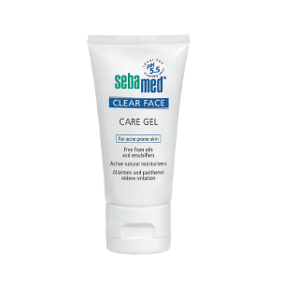

**WHAT IT DOES:** Sebamed Claer Face Care Gel is the moisturizing gel against pimples, blackheads and blemishes with a pH value of 5.5. When skin is dehydrated or irritated through intensive cleansing or acne therapy, the care gel eliminates a feeling of tightness, roughness and flaking through hyaluronic acid and allantoin, without stimulating the formation of new pimples through oils or emulsifiers. Aloe vera soothes the irritated skin. Panthenol encourages its re-generation. Contains no colorants or perfume substances.

**HOW TO USE:** Apply on the throughly cleansed skin a small amount of Clear Face Care Gel and distribute evenly on the entire face.

**PRICE:** ₱ 908.00

**BENEFICIAL INGREDIENTS:** 5/12 ingr.

**DEBATABLE INGREDIENTS:** 2/12 ingr.

PRICES (1000 above)

1. **CeraVe Foaming Facial Cleanser (237ml)**

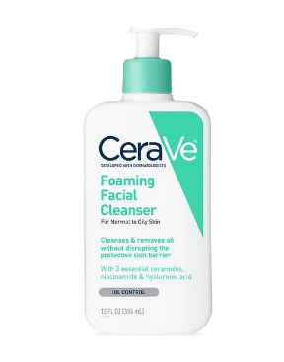

**WHAT IT DOES:** A foaming facial cleanser is ideal for removing excess oil, dirt and makeup—and choosing one that’s gentle, won’t disrupt your skin’s natural protective barrier and contains ingredients that help maintain moisture balance can make all the difference. CeraVe Foaming Facial Cleanser features ceramides, hyaluronic acid and niacinamide to help restore the skin’s barrier, attract hydration and calm the skin

**HOW TO USE:** Wet skin with lukewarm water. Massage the cleanser into skin in a gentle, circular motion and rinse

**PRICE:** ₱ 1,250

**BENEFICIAL INGREDIENTS:** 3/20 ingr.

**DEBATABLE INGREDIENTS:** 1/20 ingr.

1. **AVENE Cleanance Cleansing Gel (400ml)**

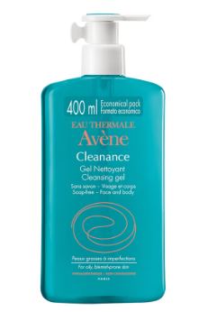

**WHAT IT DOES:** This cleansing gel gently removes impurities from the skin and helps reduce excess sebum. It leaves the skin clean, clear and refreshed.

**HOW TO USE:** Cleanses and remove impurities and reduce excess sebum for oily and blemish prone skin.

**PRICE:** ₱ 2,160

**BENEFICIAL INGREDIENTS:** 3/20 ingr.

**DEBATABLE INGREDIENTS:** 2/20 ingr.

1. **Kate Somerville Daily Foaming Cleanser (50 ml)**

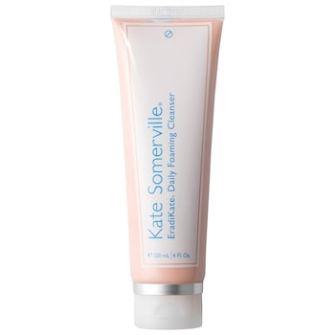

**WHAT IT DOES:** The medicated daily foaming face wash contains 3% Sulfur to delivers clinical strength cleansing without irritation. See visibly clearer skin with continued use.

**HOW TO USE:** Use the facial cleanser twice a day, AM and PM. Apply a small amount to face and massage for 30 seconds. Rinse and gently pat dry.

**PRICE:** ₱ 1, 340

**BENEFICIAL INGREDIENTS:** 5/23 ingr.

**DEBATABLE INGREDIENTS:** 2/23 ingr.